A civil law case is a dispute between 2 people about a matter which affects only them. For example, if someone owed you money and would not repay it, it is a civil matter; only you can take the person to court to get the money from them. In a dispute between neighbours over an overhanging tree, a neighbour might take the person living next to them to court if they were unable to solve a dispute over the tree in any other way.
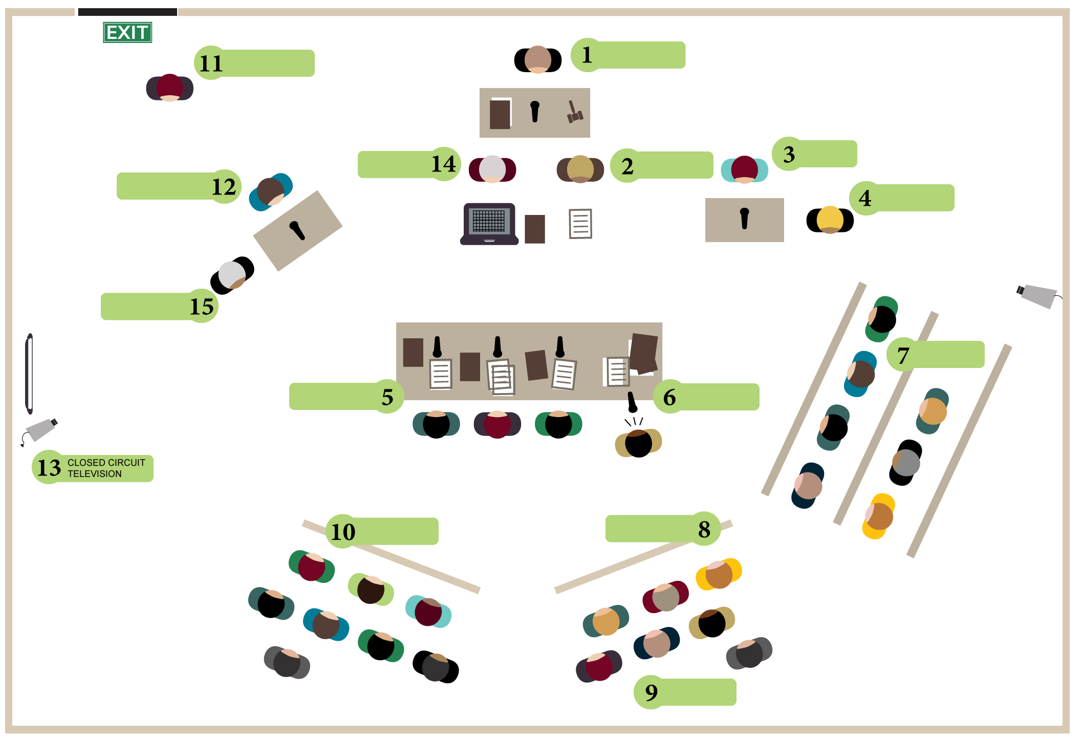
A criminal law case involves a situation in which a person has done something which is seen as a threat to the whole community as well as to victims. Theft, murder and physical assault are examples of criminal acts. The ‘state---meaning the government--takes responsibility for taking people accused of these crimes to court on behalf of the whole. In a criminal law case, the aim is to decide what happened in a situation and if someone broke the law.

Label each role title with the matching number on the diagram:
NO. | TITLE | NO. | TITLE | NO. | TITLE
13 | Closed circuit television |  | Court or Sheriff’s officer |  | Judge or judicial officer
 | Accused person |  | Witness |  | Judge’s associate
 | Court reporter or transcriber |  | Defence lawyer |  | Prosecutor
 | Jurors |  | Interpreter |  | Support person
 | Media |  | Public |  | Corrective service officer

List 5 situations that could lead to a civil law case and a criminal law case.
CIVIL LAW | CRIMINAL LAW
1.  2.  3.  4.  5. | 1.  2.  3.  4.  5.
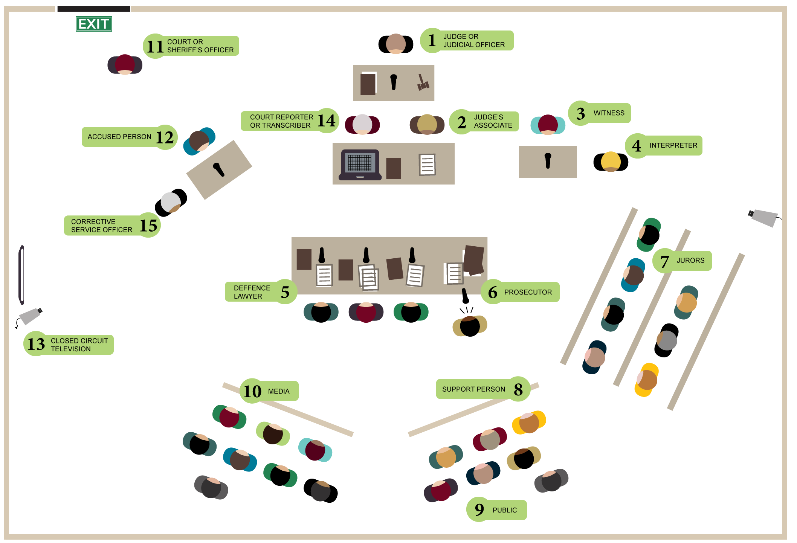

Courtroom roles, solution:

