Scoring instructions
Decide which difficulty level your group will attempt. You may like to consult with your teacher for guidance. If you finish early, move on to the next level.
Level 1 – (least difficult) – Call ‘Bingo’ after your group has found examples for any 2 horizontal rows
Level 2 – Call ‘Bingo’ after your group has found examples for one horizontal row and one vertical column
Level 3 – Call ‘Bingo’ after your group has found examples for any 2 vertical columns
Level 4 (Expert) – Call ‘Bingo’ after your group has found examples for all 17 goals

Table to record your answers
Before you can cross a goal off your Bingo sheet, you must use this table to record an example of how Australian aid is helping to achieve the goal in a country in Asia or the Pacific. Goal 3 – Good Health and Wellbeing – has already been done for you. To find examples, go to the Where we give aid map on the DFAT website. Select a nation and refer to Our results and/or the Aid fact sheet to read about the impact Australian aid is having in that country.
GOAL | COUNTRY | RESULT ACHIEVED THANKS TO AUSTRALIAN AID
1
2
3 | Papua New Guinea | Over 3.3 million children vaccinated against polio
4
5
6
7
8
9
10
11
12
13
14
15
16
17

Cross out a goal when you have added it to your table.  See the scoring instructions for when you can call “Bingo”. | 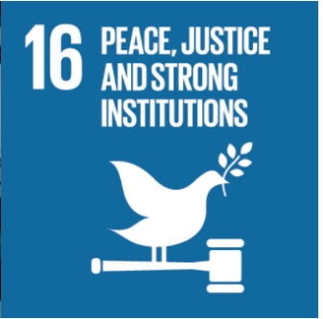 | 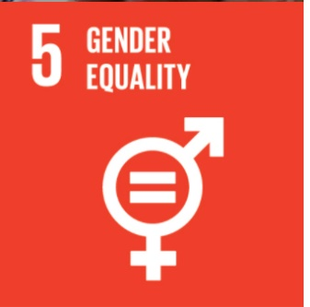
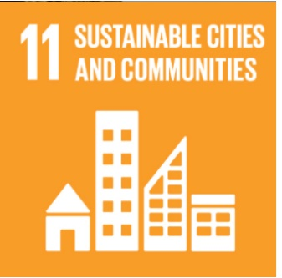 | 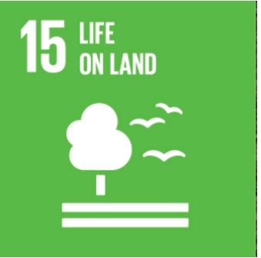 | 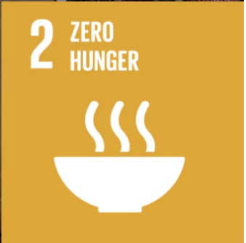
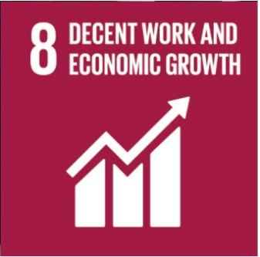 |  | 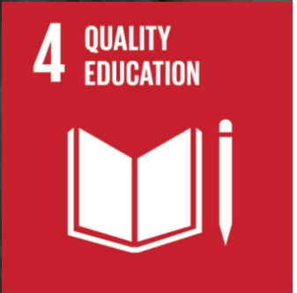
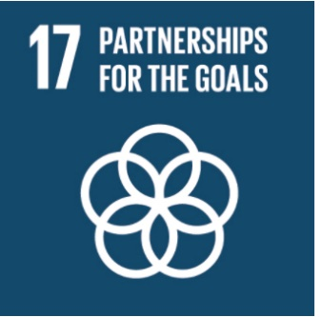 | 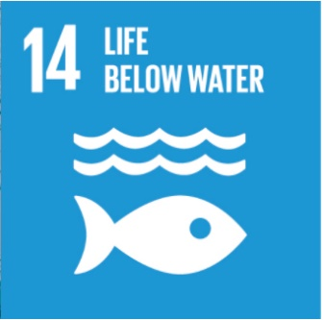 | 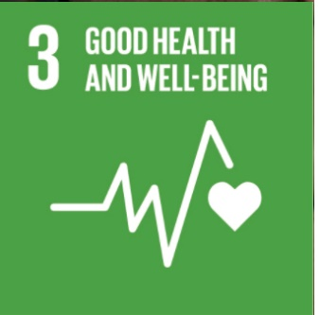
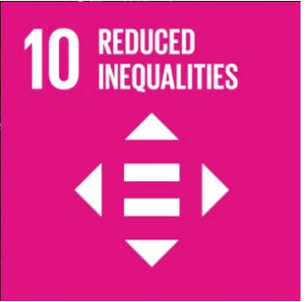 |  | 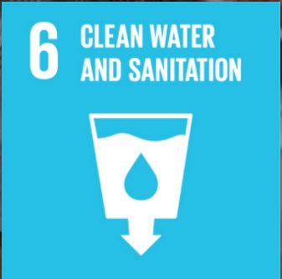
 | 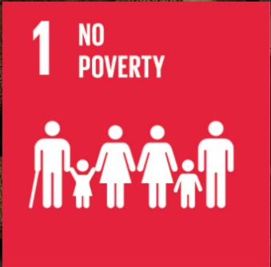 | 