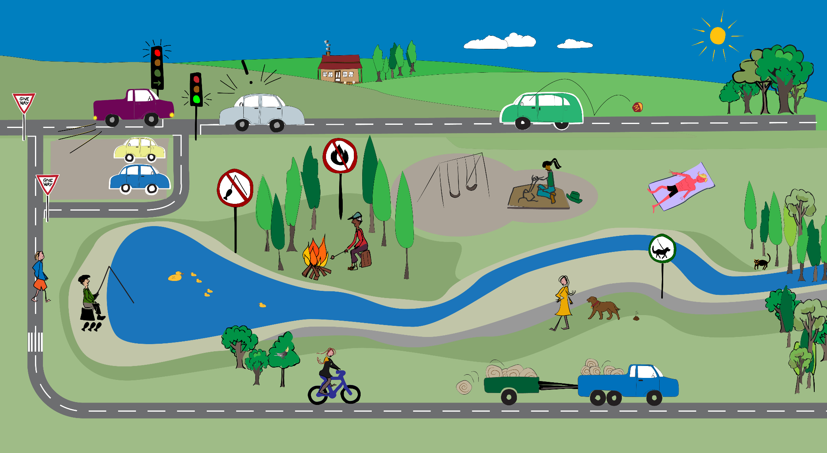 ­

|  |  |  |  |
| --- | --- | --- | --- |
| Identify 3 laws: |  | Identify 3 rules: |  |