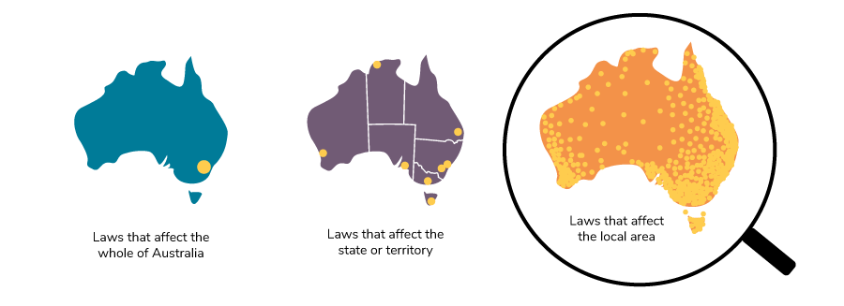

What is the name of this local council/shire/government?

Where is it?

How many people live in this local area?

What are some of the services they look after?

What are some things the local government has been working on lately?

What is something you would want to contact one of your local representatives about?

Other interesting information.

